Atatus Dashboard

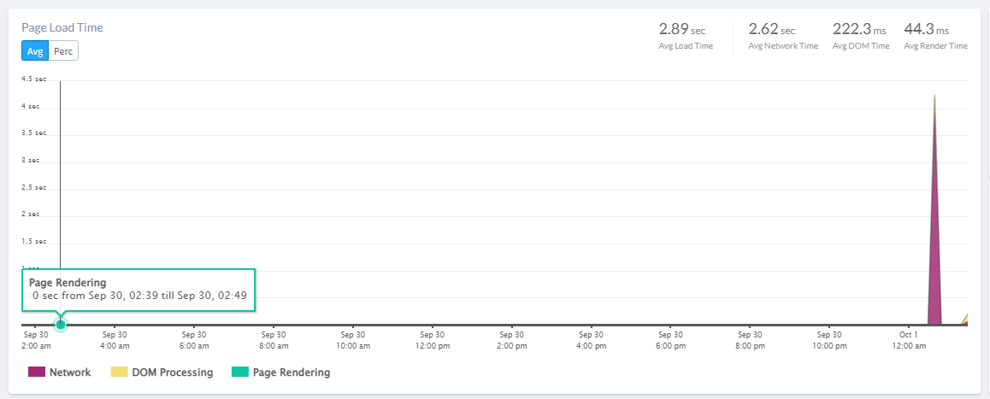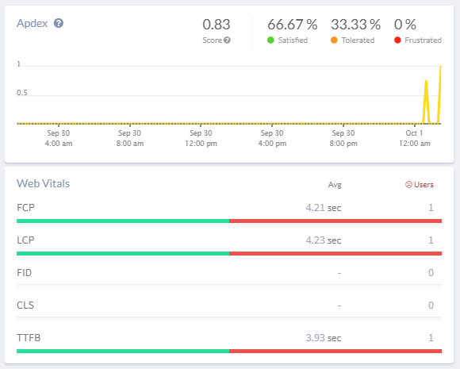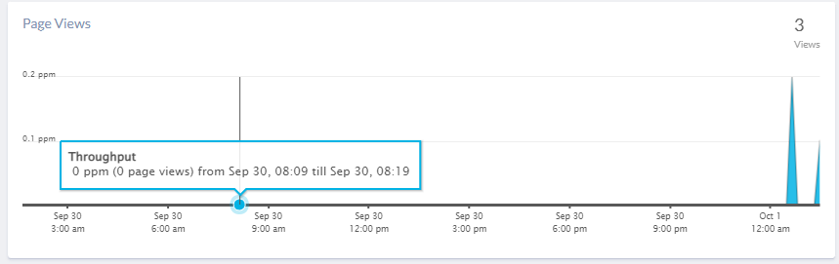

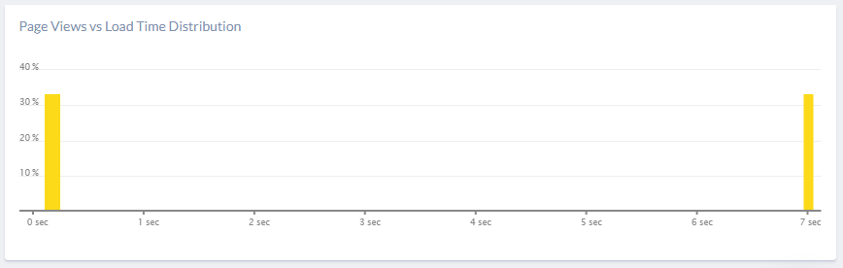

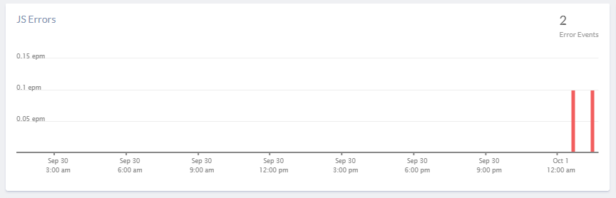

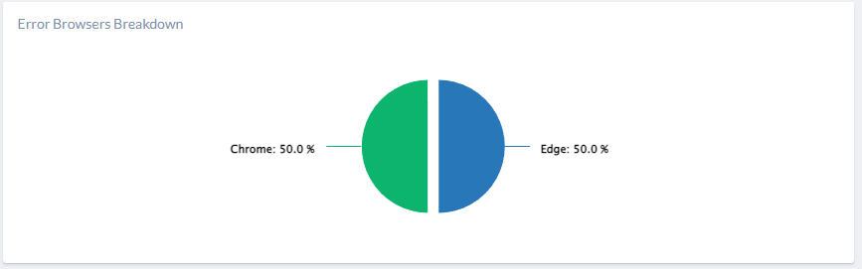

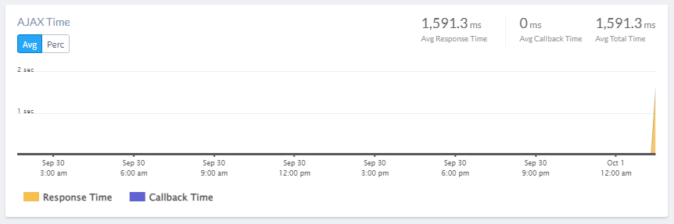

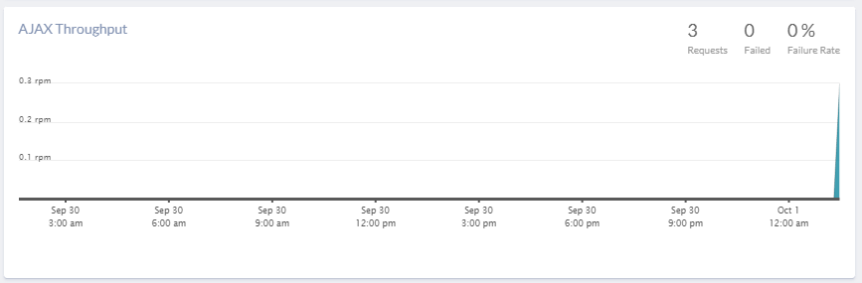

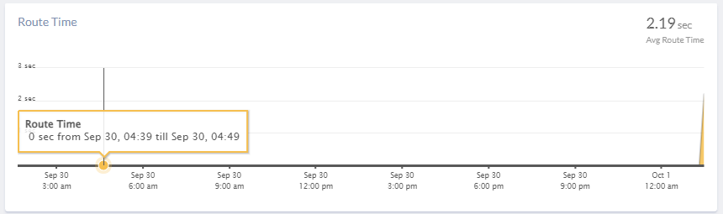

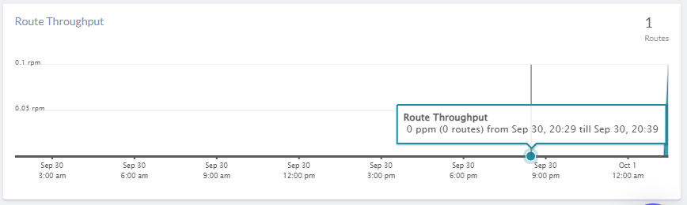

The JS Errors section shows two errors, one is intentionally set up by myself (Test Atatus Setup), one is Network Error.

Test Atatus Setup Error could be resolved by removing atatus.notify(new Error('Test Atatus Setup')) in Index.js.

Network Error, first I thought it might be the logo in index.html file so I removed it but it doesn’t seem the reason of this error. I also realized it’s only triggered when I cleared my cookies and then log in again.

Apdex score is 0.93. Web Vitals section indicates LCP(largest contentful paint)and TTFB(Time to first Byte) could be improved.